1.WAP to represent the stack operation to manage Peter’s shirts in to a cupboard

#include<stdio.h>

int stack[100],choice,n,top,x,i;

void push(void);

void pop(void);

void display(void);

int main()

{

top=-1;

printf("\n Enter the size of STACK[MAX=100]:");

scanf("%d",&n);

printf("\n\t STACK OPERATIONS USING ARRAY");

printf("\n\t--------------------------------");

printf("\n\t 1.PUSH\n\t 2.POP\n\t 3.DISPLAY\n\t 4.EXIT");

do

{

printf("\n Enter the choice:");

scanf("%d",&choice);

switch(choice)

{

case 1:

{

push();

break;

}

case 2:

{

pop();

break;

}

case 3:

{

display();

break;

}

case 4:

{

printf("\n\t EXIT POINT ");

break;

}

default:

{

printf ("\n\t Please Enter a Valid peter shirt number(1/2/3/4)");

}

}

}

while(choice!=4);

return 0;

}

void push()

{

if(top>=n-1)

{

printf("\n\tSTACK is over flow");

}

else

{

printf(" Enter a peter shirt no to be pushed:");

scanf("%d",&x);

top++;

stack[top]=x;

}

}

void pop()

{

if(top<=-1)

{

printf("\n\t Stack is under flow");

}

else

{

printf("\n\t The popped shirt number is %d",stack[top]);

top--;

}

}

void display()

{

if(top>=0)

{

printf("\n The elements in STACK \n");

for(i=top; i>=0; i--)

printf("\n%d",stack[i]);

printf("\n Press Next Choice");

}

else

{

printf("\n The STACK is empty");

}

}

Output

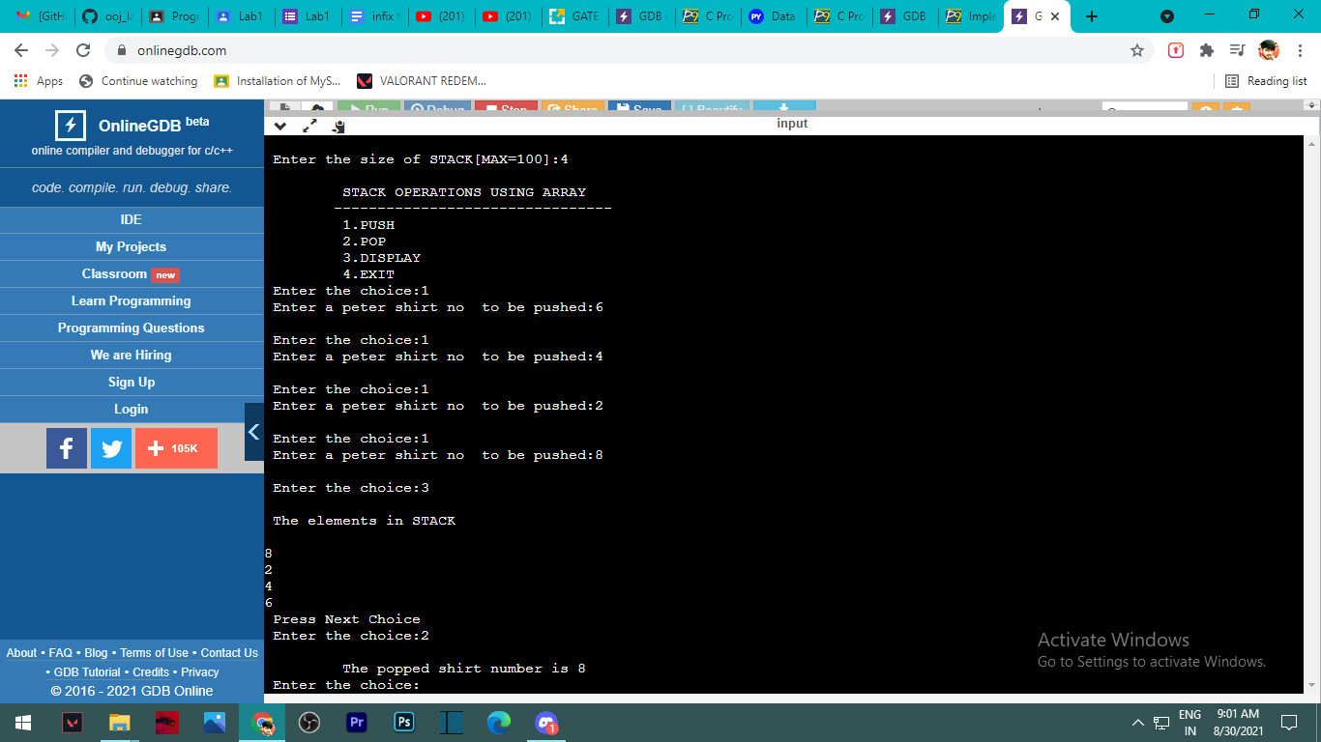

2. WAP to convert an expression from Infix to Postfix using

#include<stdio.h>

#include<ctype.h>

char stack[100];

int top = -1;

void push(char x)

{

stack[++top] = x;

}

char pop()

{

if(top == -1)

return -1;

else

return stack[top--];

}

int priority(char x)

{

if(x == '(')

return 0;

if(x == '+' || x == '-')

return 1;

if(x == '\*' || x == '/')

return 2;

return 0;

}

int main()

{

char exp[100];

char \*e, x;

printf("Enter the expression : ");

scanf("%s",exp);

printf("\n");

e = exp;

while(\*e != '\0')

{

if(isalnum(\*e))

printf("%c ",\*e);

else if(\*e == '(')

push(\*e);

else if(\*e == ')')

{

while((x = pop()) != '(')

printf("%c ", x);

}

else

{

while(priority(stack[top]) >= priority(\*e))

printf("%c ",pop());

push(\*e);

}

e++;

}

while(top != -1)

{

printf("%c ",pop());

}return 0;

}

Output

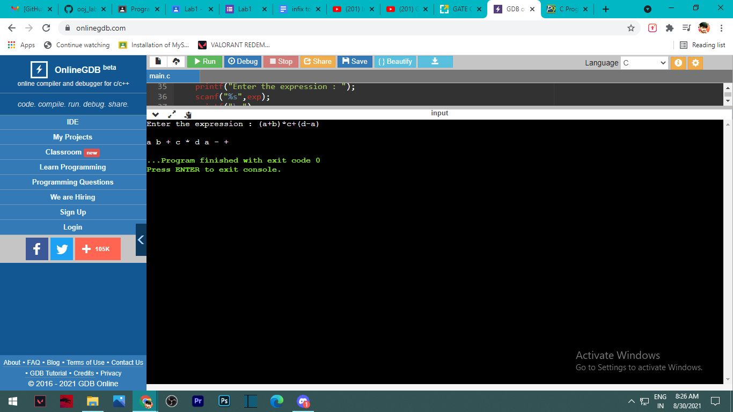

WAP to evaluate a given expression using stack

#include<stdio.h>

int stack[20];

int top = -1;

void push(int x)

{

stack[++top] = x;

}

int pop()

{

return stack[top--];

}

int main()

{

char exp[20];

char \*e;

int n1,n2,n3,num;

printf("Enter the expression :: ");

scanf("%s",exp);

e = exp;

while(\*e != '\0')

{

if(isdigit(\*e))

{

num = \*e - 48;

push(num);

}

else

{

n1 = pop();

n2 = pop();

switch(\*e)

{

case '+':

{

n3 = n1 + n2;

break;

}

case '-':

{

n3 = n2 - n1;

break;

}

case '\*':

{

n3 = n1 \* n2;

break;

}

case '/':

{

n3 = n2 / n1;

break;

}

}

push(n3);

}

e++;

}

printf("\nThe result of expression %s = %d\n\n",exp,pop());

return 0;

}

Output

